Examiner Bio.
ATOD Examiner for almost 15 years with The Australian Teachers of Dancing Ltd. Examining has taken Tania to the UK, Singapore, Hong Kong, Thailand, Indonesia, and New Zealand.
Registered with the Australian Counselling Association (A.C.A). Tania is extremely passionate about sharing lived experiences to inspire others. A regular speaker on topics including mental health and motivation to encourage women in their journey of self-belief.

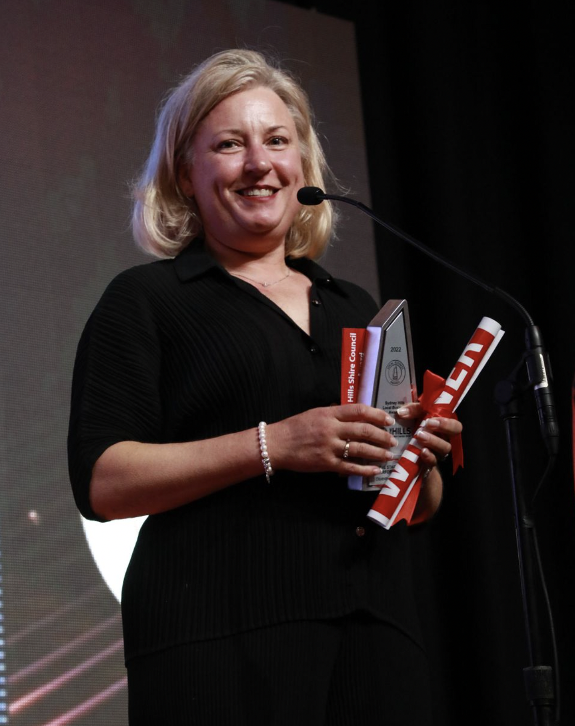

Mrs MacLeod.
2022 WINNER Hills Business Awards Inaugural Disability Inclusion
2019 WINNER Western Sydney Women of the Year
2019 WINNER Outstanding Woman in Leadership.
2016 NSW STATE Finalist in Business Ethics
2015 WINNER Business Leader of the Year - Western Sydney Awards for Business
Excellence (WSABE) Chamber of Commerce.

Director of The Stage Door Performing Arts formerly Tania’s Strictly Dancing for the last 30 years.
Over 10,000 students have experienced the joy of the performing arts with Tania, over 50 teachers trained and 4 International Disney dance tours conducted.
Tania has enjoyed adjudicating internationally and in public, private and special education schools throughout Sydney.
Examining Tip: Apply the ethos that your thoughts create your actions to design your desired outcome of success - in class, the examining room and life.

Mrs MacLeod.

Examiner catering requirements.

- Stringent Hygiene procedures followed with all preparation of meals and refreshments
- Cutlery to be supplied with all meals including serviettes

Examiner table requirements.

- Bottled water and a glass on the table
- Hand Sanitiser
- Tissues
- Tablecloth
- Small rubbish bin under the table
- An extension lead should be available for Examiners using laptops
- Teachers MUST provide the Examiner/s with a suitable chair (supporting back is recommended)
- It is important to ensure the Examiner is comfortable in all climates, this may require additional heating or fans

Examiner preferences.
- Preferred Title when examining
Mrs. MacLeod

- Use of Laptop in the Exam Room (Teacher to supply electrical lead / power board)
Yes

- Allergies / Foods that cannot be eaten
N/A

- Morning Tea - Preferred Beverage and Snack
Sweet or Savoury

- Lunch - Preferred Beverage and Food
Anything is great

- Afternoon Tea - Preferred Beverage and Snack
Sweet or Savoury

