With 40 years dance teaching experience, Simone loves sharing her knowledge and expertise to help others on their dance journey.
She feels the most satisfaction when students leave the examination room with a smile on their faces, excited to return for the next exam. In the future, Simone hopes to reconnect with studios where she has previously examined and get to know more teachers and students in the ever-expanding ATOD family.
Teaching technique tip: Focus on postural alignment as a solid foundation to enable all other technical aspects.

Examiner Bio.

As a national and international examiner for the Australian Teachers of Dancing (ATOD), Simone enjoys sharing her passion for dance with both teachers and students and promotes a positive and encouraging examination experience for everyone.

She is an ATOD Licentiate member and holds a Bachelor of Education and a Graduation Diploma in Dance Instruction from QUT. From her early background as a studio owner in a small west Queensland town, Simone gained first-hand experience of how dance can enrich the lives of rural students and this is why she has a special interest in promoting dance in rural areas.

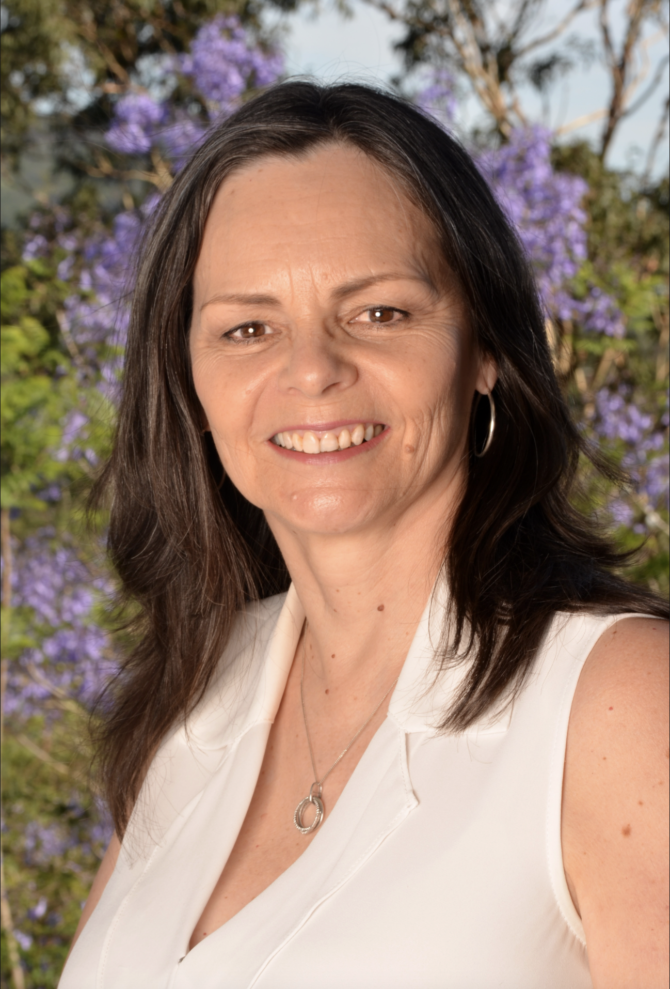

Ms Dawson.

Examiner catering requirements.

- Stringent Hygiene procedures followed with all preparation of meals and refreshments
- Cutlery to be supplied with all meals including serviettes

Ms Dawson.

Examiner table requirements.

- Bottled water and a glass on the table
- Hand Sanitiser
- Tissues
- Tablecloth
- Small rubbish bin under the table
- An extension lead should be available for Examiners using laptops
- Teachers MUST provide the Examiner/s with a suitable chair (supporting back is recommended)
- It is important to ensure the Examiner is comfortable in all climates, this may require additional heating or fans

Examiner preferences.
- Preferred Title when examining
Ms Dawson

- Use of Laptop in the Exam Room (Teacher to supply electrical lead / power board)
Yes

- Allergies / Foods that cannot be eaten
None

- Morning Tea - Preferred Beverage and Snack
Tea- milk with one sugar / Either sweet or savoury

- Lunch - Preferred Beverage and Food
Sandwiches (any bread, egg and lettuce, ham and cheese, chicken, avocado) /wraps/ pasta / soup / quiche

- Afternoon Tea - Preferred Beverage and Snack
Either sweet or savoury

