After moving to Sydney to study a Certificate IV in Performing Arts at Brent Street and working as a performer, I began teaching for our family business, The Allenby Dance Studio. Soon after, I realized the fire inside me to teach and nurture young dancers. There is nothing more rewarding than watching your students achieve their goals, whether it is nailing a double turn for the first time or getting their dream job as a performer. Each and every achievement is just as exciting. I am proud of the many success stories I have been a part of and enjoy the challenges of running a successful school and mentoring our teachers.
Throughout my years of teaching I have received all ATOD teaching qualification holding a Licentiate Diploma, Certificate IV in Dance Teaching and Management and Certificate IV in Training and Assessment. In 2017 I completed my Examiner Training and began working for ATOD. Over the past 5 years I have been fortunate enough to examine both throughout Australia and internationally. It has been a privilege to co-create the updated Jazz Moves Syllabus.
I am so passionate about creating an environment where students thrive and feel comfortable and able to perform at their best. Examining has allowed me to combine my love of dance, sharing my knowledge and travel into one beautiful experience. Dance has always been a part of my life and my happy place so I feel very privileged to be a part of so many young students.
Examination Tip: Your examiner wants you to achieve and give your best performance, we love when you are proud and confident in what you have done. Breathe, Present and Enjoy!

Examiner Bio.
- Studio Director- The Allenby Dance Studio
- Examiner for The Australian Teachers of Dancing
- A.T.O.D. Licentiate Teaching Diploma
- Certificate IV Performing Arts- Brent Street, Sydney
- Senior First Aid Certificate
- Certificate IV in Dance Teaching and Management
- Certificate IV in Training and Assessment
- Positive Notice Blue Card
As a student I grew up completing all exams in Ballet, Jazz and Tap with ATOD including the prestigious Avril Binzer Award and CSTD Jazz Award. I was a successful winner and place getter at Scholarships both State and Australasian as well as ATOD Competitions and overseas tours, eisteddfods and concerts. I love the opportunities ATOD has provided me and continues to offer students today.

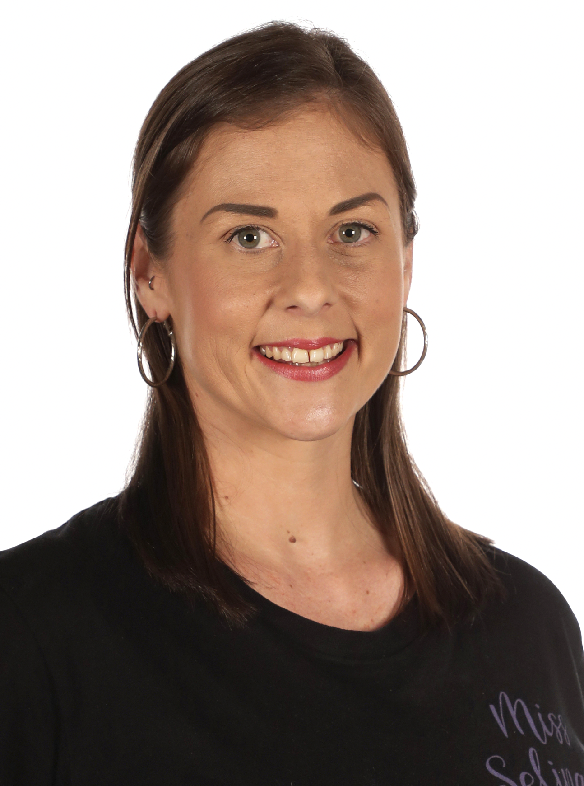

Ms Holdstock.

Ms Holdstock.

Examiner catering requirements.

- Stringent Hygiene procedures followed with all preparation of meals and refreshments
- Cutlery to be supplied with all meals including serviettes

Examiner table requirements.

- Bottled water and a glass on the table
- Hand Sanitiser
- Tissues
- Tablecloth
- Small rubbish bin under the table
- An extension lead should be available for Examiners using laptops
- Teachers MUST provide the Examiner/s with a suitable chair (supporting back is recommended)
- It is important to ensure the Examiner is comfortable in all climates, this may require additional heating or fans

Examiner preferences.
- Preferred Title when examining
Ms. Holdstock

- Use of Laptop in the Exam Room (Teacher to supply electrical lead / power board)
Yes

- Allergies / Foods that cannot be eaten
Please no fish or sushi

- Morning Tea - Preferred Beverage and Snack
Tea- white with one sugar / sweet or savoury

- Lunch - Preferred Beverage and Food
Anything is great

- Afternoon Tea - Preferred Beverage and Snack
Sweet or savoury

