Mrs Armstrong.

Examiner Bio.

Marnie has been involved with dancing for over 45 years and has had approximately 35 years experience in teaching all age groups the art of dance.

She is an ATOD Examiner and Licentiate Teacher, the highest qualification that can be achieved with the ATOD Ltd. and has completed a Diploma of Dance Teaching and Management.

She has demonstrated and taught the ATOD syllabus to students & teachers throughout Australia & overseas. Marnie has also performed at various functions throughout Melbourne.

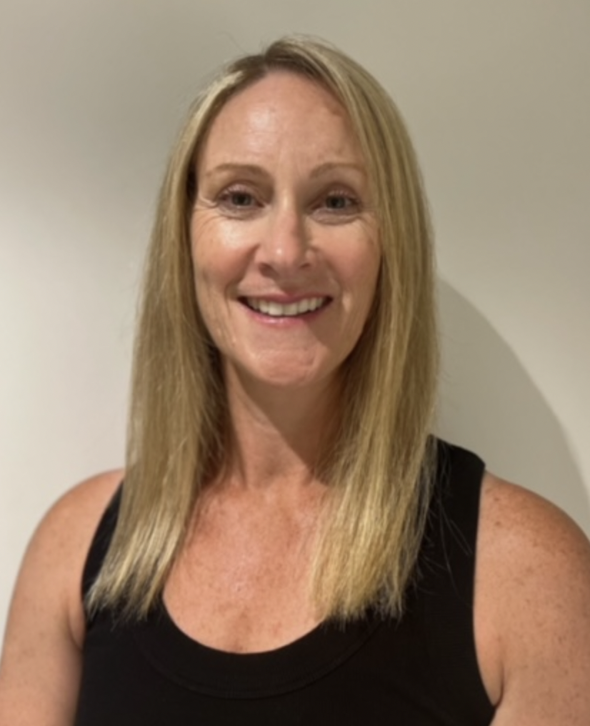

Examiner catering requirements.

- Stringent Hygiene procedures followed with all preparation of meals and refreshments
- Cutlery to be supplied with all meals including serviettes

Examiner table requirements.

- Bottled water and a glass on the table
- Hand Sanitiser
- Tissues
- Tablecloth
- Small rubbish bin under the table
- An extension lead should be available for Examiners using laptops
- Teachers MUST provide the Examiner/s with a suitable chair (supporting back is recommended)
- It is important to ensure the Examiner is comfortable in all climates, this may require additional heating or fans
Mrs Armstrong.

Examiner preferences.
- Preferred Title when examining
Mrs. Armstrong

- Use of Laptop in the Exam Room (Teacher to supply electrical lead / power board)
Yes

- Allergies / Foods that cannot be eaten
N/A

- Morning Tea - Preferred Beverage and Snack
No tea or coffee
Juice or water
Savoury

- Lunch - Preferred Beverage and Food
No butter please
Anything is great, but prefer no onion

- Afternoon Tea - Preferred Beverage and Snack
No tea or coffee
Juice or water
A little something sweet is nice in the afternoon

