Examiner Bio.
Looking back on my time as a dancer/dance teacher/studio owner, I feel very blessed to have done what I love for as long as I can remember.
I can't remember a time where dance commitments were not part of my life. As an examiner, I feel truly privileged to come into other beautiful studios, halls etc. and see the joy of dance being shared with our next generations.
ATOD is a wonderful platform from which amazing dancers are created over time.

Mrs MacCabe.

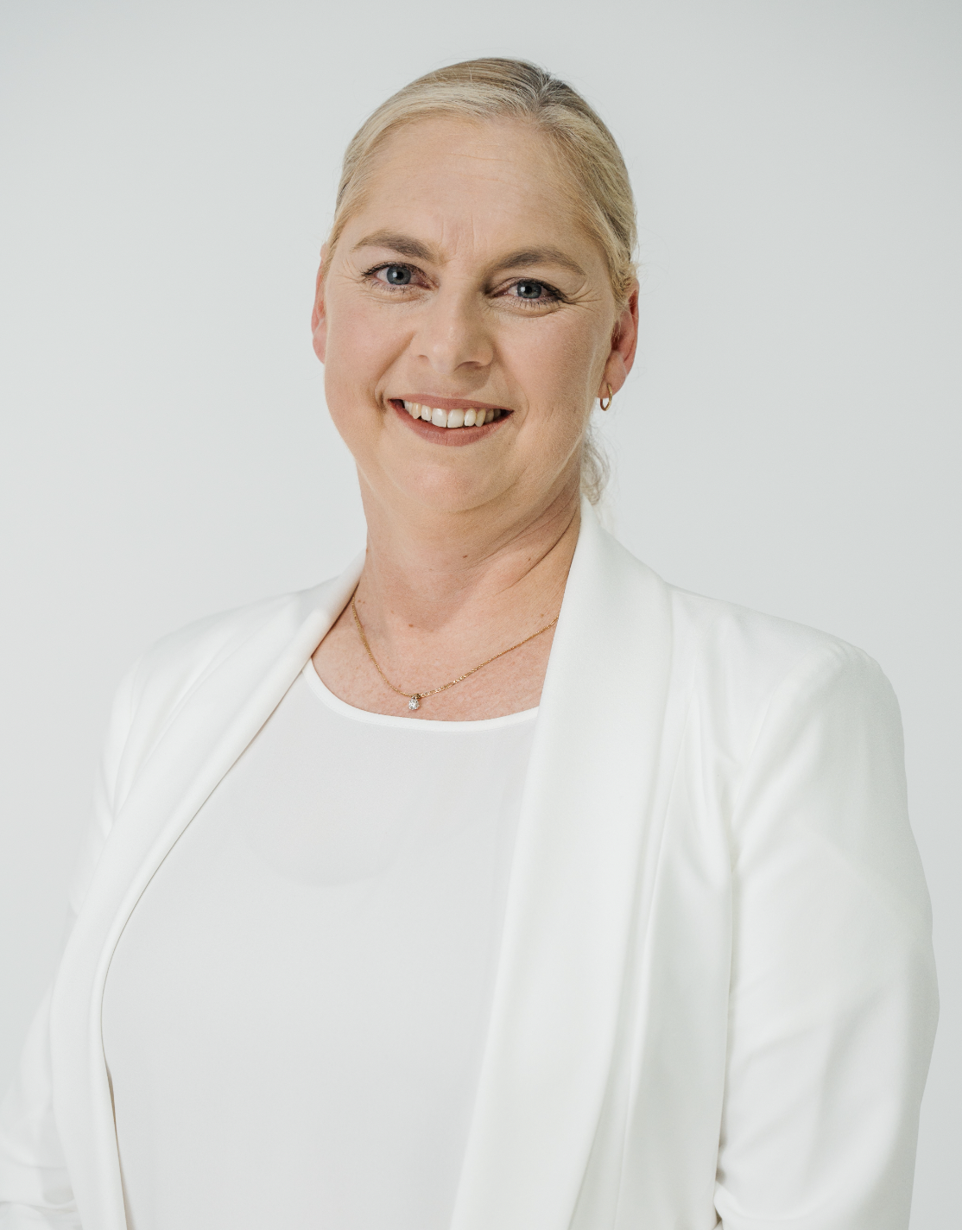

Examiner table requirements.

- Bottled water and a glass on the table
- Hand Sanitiser
- Tissues
- Tablecloth
- Small rubbish bin under the table
- An extension lead should be available for Examiners using laptops
- Teachers MUST provide the Examiner/s with a suitable chair (supporting back is recommended)
- It is important to ensure the Examiner is comfortable in all climates, this may require additional heating or fans

Mrs MacCabe.

Examiner catering requirements.

- Stringent Hygiene procedures followed with all preparation of meals and refreshments
- Cutlery to be supplied with all meals including serviettes

Examiner preferences.
- Preferred Title when examining
Mrs. MacCabe

- Use of Laptop in the Exam Room (Teacher to supply electrical lead / power board)
Yes

- Allergies / Foods that cannot be eaten
None

- Morning Tea - Preferred Beverage and Snack
Either sweet or Savoury. Coffee, weak, white with 1 sugar

- Lunch - Preferred Beverage and Food
Sandwiches (e.g. ham & salad), quiche, salad, soup. Fruit Juice

- Afternoon Tea - Preferred Beverage and Snack
Either sweet or Savoury. Coffee, weak, white with 1 sugar

