Examiner Bio.
ATOD President, Licentiate Diploma, Examiner, Cert IV – Dance Teaching and Management, Diploma – Dance Teaching and Management, Cert IV in Training and Assessment, Certificate in Dance – QUT

Leah is not only the President of ATOD, but the proud owner of Barrick Dance Centre, a fully qualified Dance Teacher and Examiner, and a loving wife and mother. Ever since Barrick Dance Centre opened its doors in 1995, she has dedicated herself to providing a safe, happy and loving environment for kids of all ages to dance.

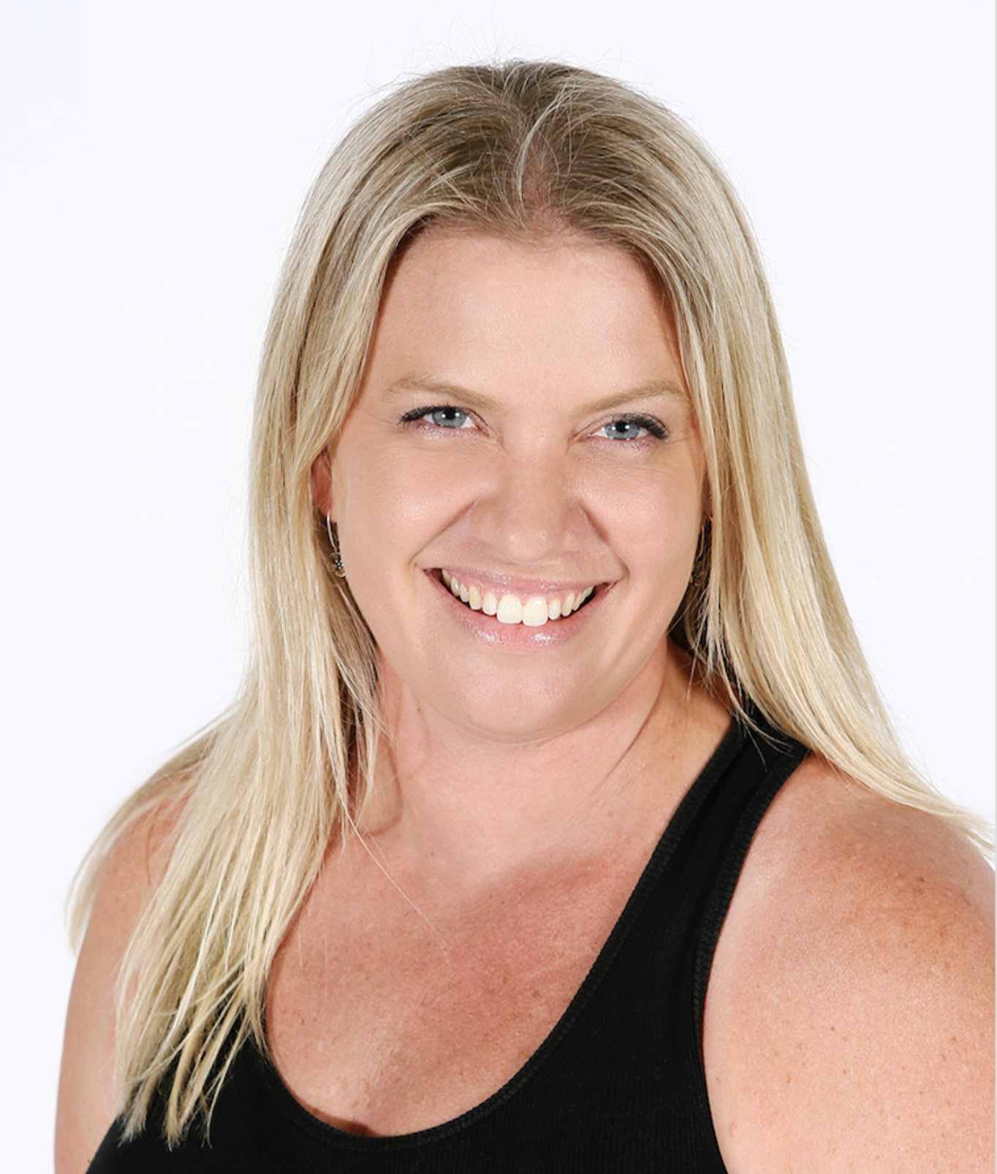

Mrs Belford.

Leah cares about the little things, and encourages and cares for each and every child in the BDC Dance Family. When you walk into the studio she will always be your number one support team.

Examiner table requirements.

- Bottled water and a glass on the table
- Hand Sanitiser
- Tissues
- Tablecloth
- Small rubbish bin under the table
- An extension lead should be available for Examiners using laptops
- Teachers MUST provide the Examiner/s with a suitable chair (supporting back is recommended)
- It is important to ensure the Examiner is comfortable in all climates, this may require additional heating or fans

Mrs Belford.

Examiner catering requirements.

- Stringent Hygiene procedures followed with all preparation of meals and refreshments
- Cutlery to be supplied with all meals including serviettes

Examiner preferences.
- Preferred Title when examining
Mrs. Belford

- Use of Laptop in the Exam Room (Teacher to supply electrical lead / power board)
Yes

- Allergies / Foods that cannot be eaten
Seafood

- Morning Tea - Preferred Beverage and Snack
Black coffee, no sugar / Either Sweet or Savoury

- Lunch - Preferred Beverage and Food
Black Coffee, no sugar or Juice / I am happy with whatever is served and is easiest for the studio

- Afternoon Tea - Preferred Beverage and Snack
Black coffee, no sugar / Either Sweet or Savoury

