Janelle has been fortunate to be involved with the development of the RTO within ATOD and also the overseas teachers’ program which is constantly growing. This year she celebrates 50 years of teaching at her Dance School and hopes that this continues into the future.

“My love of dance and dance education is a passion that I hope to share with young dancers and teachers alike”.

Examiner Bio.
Janelle has a background as a young dancer in Ballet, Tap, Jazz, Highland and Irish Dancing as well as Musical Theatre. In NSW she taught High School Students up to HSC level in Dance and PDHPE and have a Dance School on the Central Coast.

Janelle has been an examiner for over 30 years, initially with SATD and then ATOD when this was founded and is a Director, Examiner and Lifetime member with ATOD. She enjoys the support and friendships that exist between members both in Australia and with ATODI members overseas.

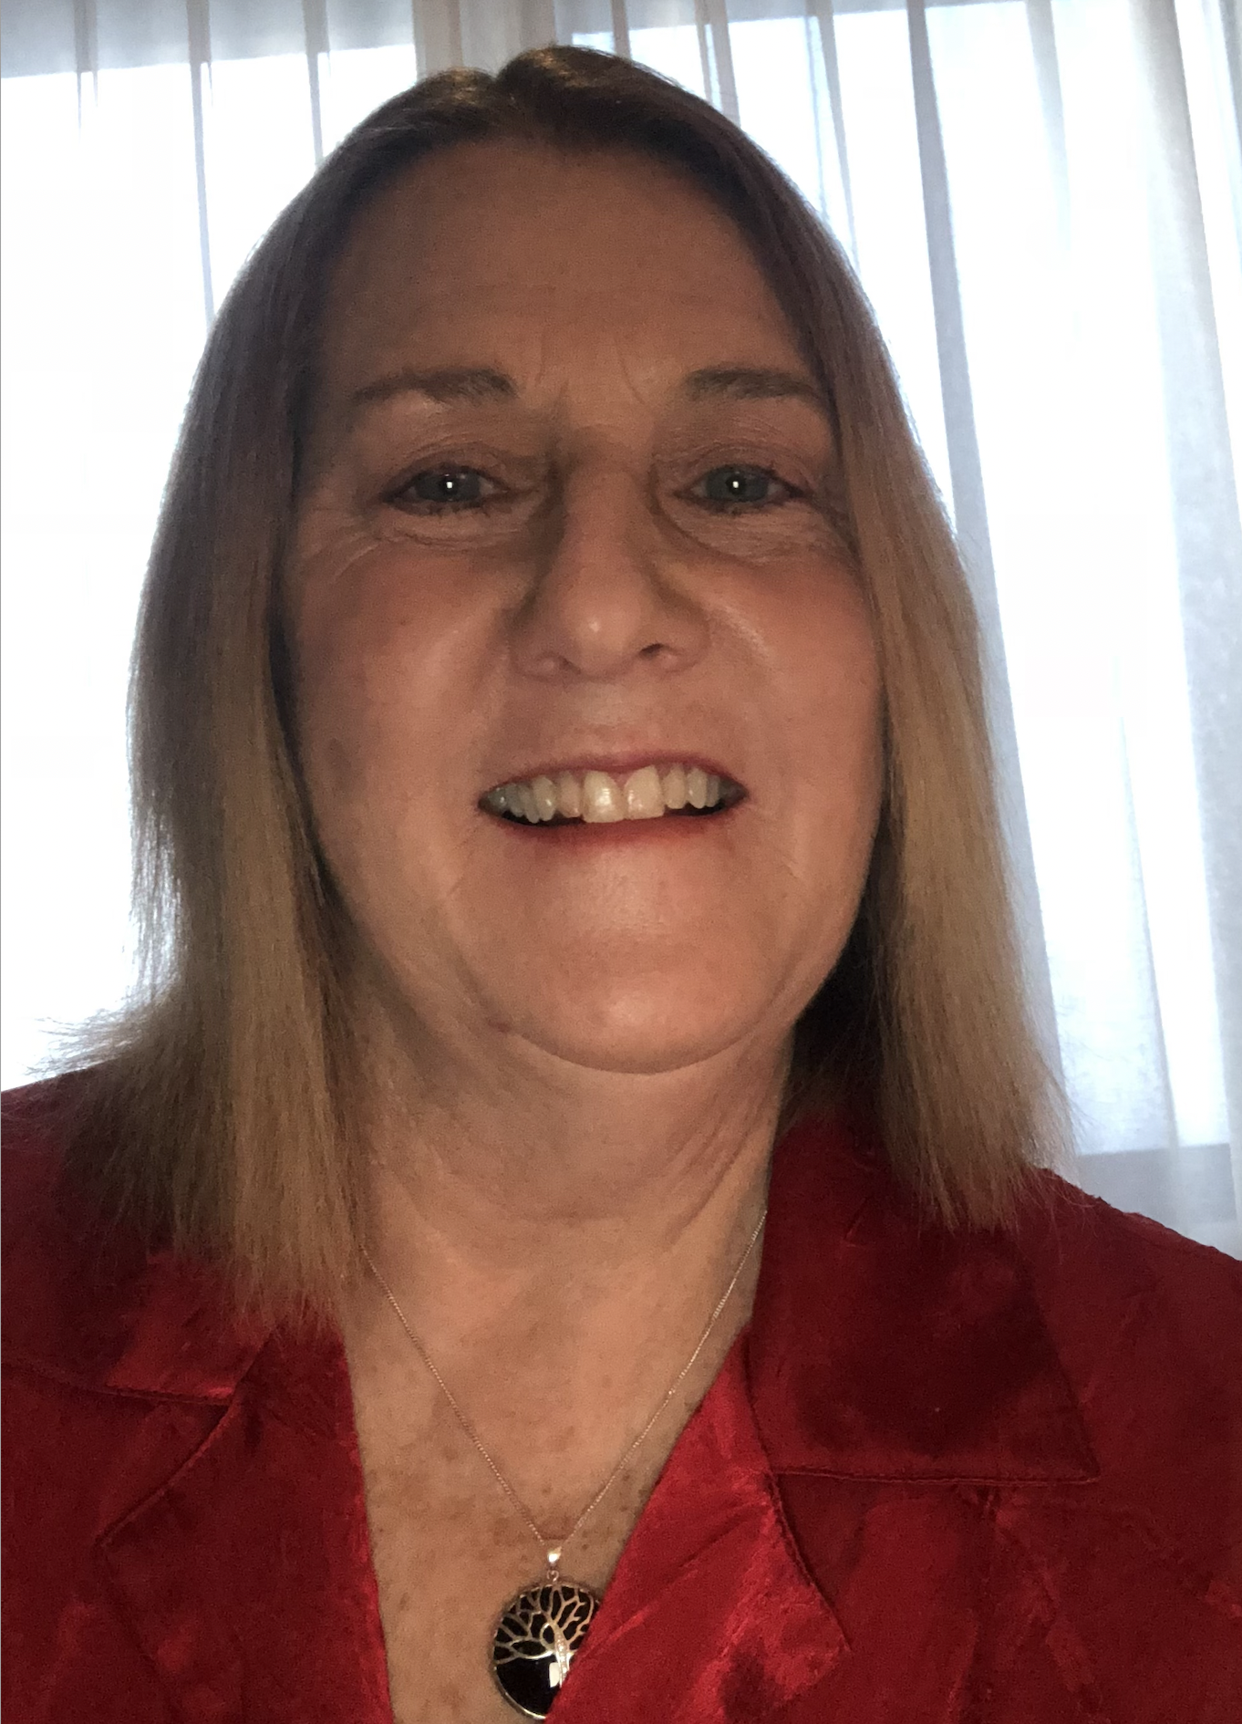

Miss Smith.

Examiner table requirements.

- Bottled water and a glass on the table
- Hand Sanitiser
- Tissues
- Tablecloth
- Small rubbish bin under the table
- An extension lead should be available for Examiners using laptops
- Teachers MUST provide the Examiner/s with a suitable chair (supporting back is recommended)
- It is important to ensure the Examiner is comfortable in all climates, this may require additional heating or fans

Mrs Smith.

Examiner catering requirements.

- Stringent Hygiene procedures followed with all preparation of meals and refreshments
- Cutlery to be supplied with all meals including serviettes

Examiner preferences.
- Preferred Title when examining
Miss Smith

- Use of Laptop in the Exam Room (Teacher to supply electrical lead / power board)
Yes

- Allergies / Foods that cannot be eaten
Seafood

- Morning Tea - Preferred Beverage and Snack
Sweet snack

- Lunch - Preferred Beverage and Food
Toasted sandwich

- Afternoon Tea - Preferred Beverage and Snack
Sweet snack

