Examiner Bio.
I love getting to see the effort dancers go to when they are in their exam. The joy on their faces when they've achieved each level is so rewarding.
I look for students who are working hard, enjoying their dance, showing respect for the art of dance, and who are extending themselves technically.

Mrs O’Hehir.

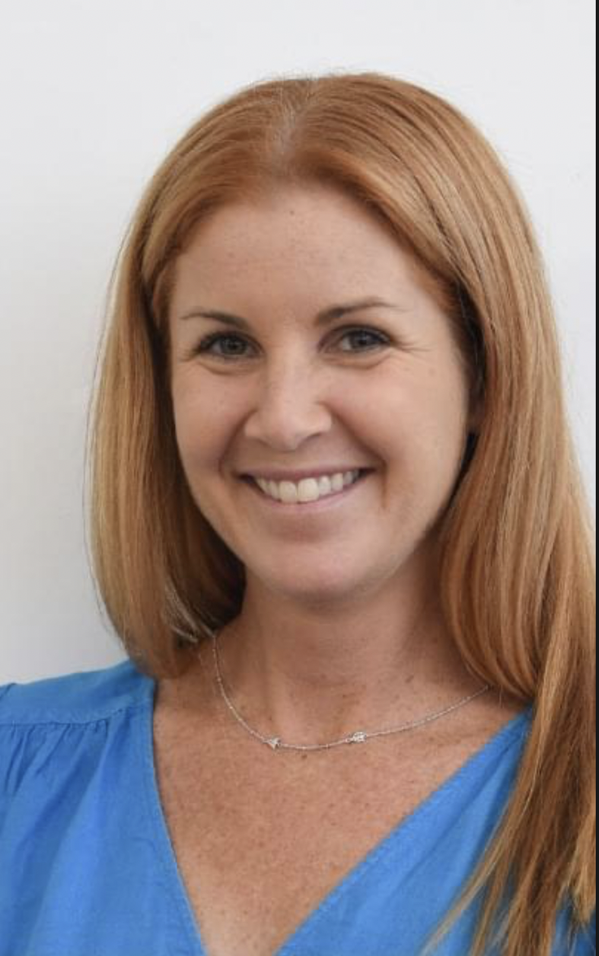

Examiner table requirements.

- Bottled water and a glass on the table
- Hand Sanitiser
- Tissues
- Tablecloth
- Small rubbish bin under the table
- An extension lead should be available for Examiners using laptops
- Teachers MUST provide the Examiner/s with a suitable chair (supporting back is recommended)
- It is important to ensure the Examiner is comfortable in all climates, this may require additional heating or fans

Mrs O’Hehir.

Examiner catering requirements.

- Stringent Hygiene procedures followed with all preparation of meals and refreshments
- Cutlery to be supplied with all meals including serviettes

Examiner preferences.
- Preferred Title when examining
Mrs. O’Hehir

- Use of Laptop in the Exam Room (Teacher to supply electrical lead / power board)
Yes

- Allergies / Foods that cannot be eaten
None

- Morning Tea - Preferred Beverage and Snack
Savoury

- Lunch - Preferred Beverage and Food
Any – No preferences

- Afternoon Tea - Preferred Beverage and Snack
Savoury

