In 1996, Hayley was invited as a guest teacher at the Queensland Dance School of Excellence and in the same year she was awarded a teacher’s scholarship by the Australian Institute of Classical Dance, directed by Marilyn Jones O.B.E. to study ballet teaching at the Australian Ballet School in Melbourne. In 2004, Hayley was appointed as an examiner for the Australian Teachers of Dancing. She was also a member of the ATOD Classical Ballet Syllabus Committee revising the new classical ballet syllabus.

Hayley is a third generation dance teacher and continues to be passionate about inspiring students to always dance to the very best of their ability. She believes the examination process is an important part of every dancer’s journey as it encourages the development of so many incredible skills that can be used in every part of their lives.

Examiner Bio.

Hayley Ashfield-Predl was originally trained by her mother, Nicole Ashfield. She successfully auditioned for the Bachelor of Arts (Dance) degree at the Queensland University of Technology in 1990 and graduated in 1993. At university, she majored in Choreographic Studies and Dance Analysis and as a freelance choreographer she went to high schools, private colleges and dance studios facilitating workshops and choreographing routines for various projects. Her performance career included working in the commercial dance industry and as an extra with The Australian Ballet.

Hayley commenced teaching full time at the Ashfield Ballet School in 1995 in partnership with Nicole Ashfield and in 2016 took over as studio owner & director. In November 2023, she sold her studios and closed Ashfield Ballet School after 45 successful years to pursue a new career path.

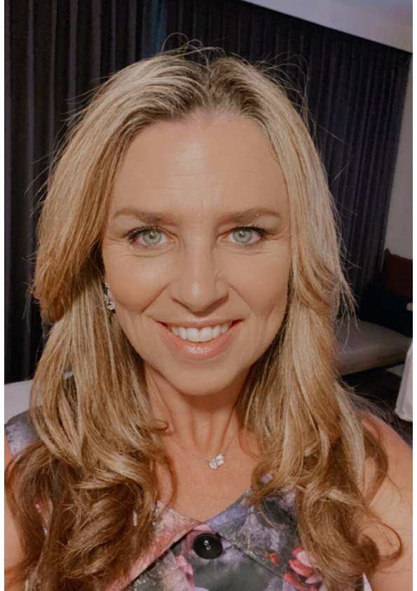

Mrs Predl.

Examiner catering requirements.

- Stringent Hygiene procedures followed with all preparation of meals and refreshments
- Cutlery to be supplied with all meals including serviettes

Mrs Predl.

Examiner table requirements.

- Bottled water and a glass on the table
- Hand Sanitiser
- Tissues
- Tablecloth
- Small rubbish bin under the table
- An extension lead should be available for Examiners using laptops
- Teachers MUST provide the Examiner/s with a suitable chair (supporting back is recommended)
- It is important to ensure the Examiner is comfortable in all climates, this may require additional heating or fans

Examiner preferences.
- Preferred Title when examining
Mrs. Predl

- Use of Laptop in the Exam Room (Teacher to supply electrical lead / power board)
Yes

- Allergies / Foods that cannot be eaten
Butter / Margarine, Chicken

- Morning Tea - Preferred Beverage and Snack
Sweet and/or Savoury, Coffee (White with no sugar) Skim milk, Cappuccino

- Lunch - Preferred Beverage and Food
Salad Sandwich; Toasted Sandwich; Sushi; Quiche, Soup, Water

- Afternoon Tea - Preferred Beverage and Snack
Coffee, Savoury

