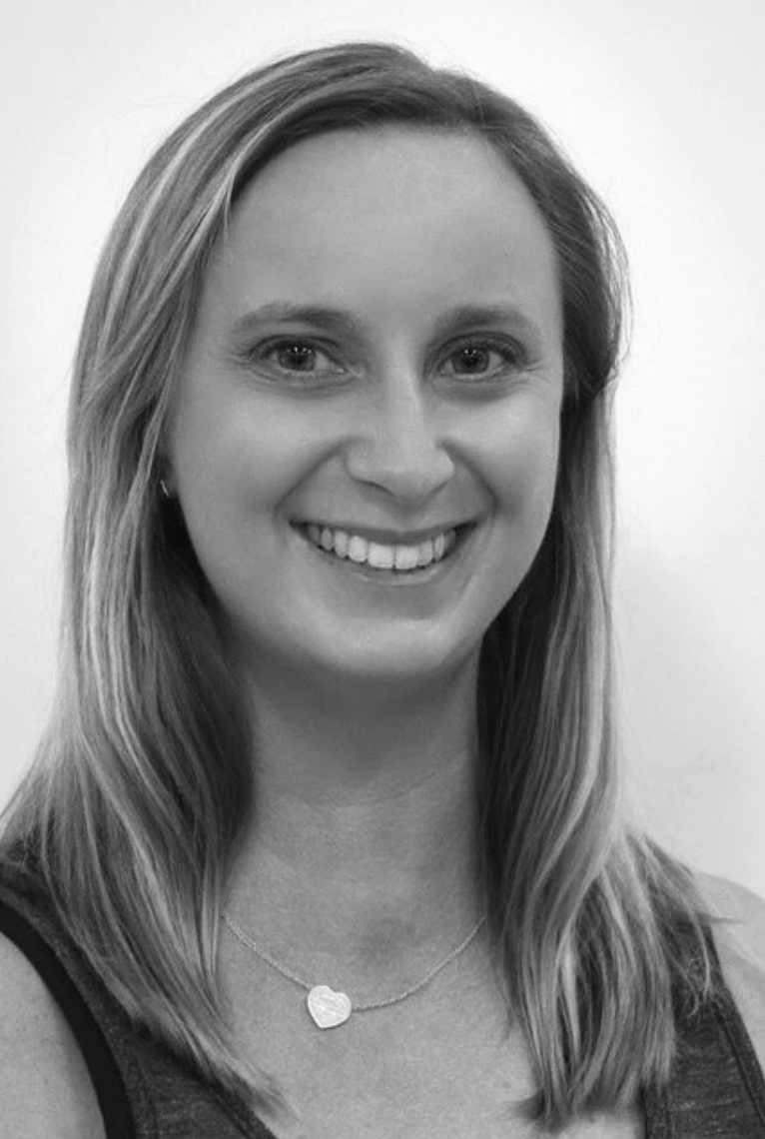

Examiner table requirements.

- Bottled water and a glass on the table
- Hand Sanitiser
- Tissues
- Tablecloth
- Small rubbish bin under the table
- An extension lead should be available for Examiners using laptops
- Teachers MUST provide the Examiner/s with a suitable chair (supporting back is recommended)
- It is important to ensure the Examiner is comfortable in all climates, this may require additional heating or fans

Ms Barritt.

Examiner catering requirements.

- Stringent Hygiene procedures followed with all preparation of meals and refreshments
- Cutlery to be supplied with all meals including serviettes

Examiner preferences.
- Preferred Title when examining
Ms Barritt

- Use of Laptop in the Exam Room (Teacher to supply electrical lead / power board)
Yes

- Allergies / Foods that cannot be eaten
No allergies

- Morning Tea - Preferred Beverage and Snack
Anything is great

- Lunch - Preferred Beverage and Food
Anything is great

- Afternoon Tea - Preferred Beverage and Snack
Anything is great

