It is very rewarding as an examiner when teachers tell me all the students have come out of the exam room smiling and have had a wonderful experience. I am privileged to have had the opportunity to examine students In Australia and Overseas for over 20 years.
I am a proud Melbournian - love to wear black, drink great coffee & enjoy the fabulous Arts & Sport our city has to offer - my AFL team is Carlton

Examiner Bio.

I love examining - I love seeing the students working diligently throughout the exam and the joy of their smiles when I give them a positive comment as to how hard they are working or how beautiful their port de bras was to watch etc.

I love meeting the teachers - especially new members on their first exam session with us - they are usually nervous to begin but I always assure them that we will have a great day and I will assist them wherever needed.

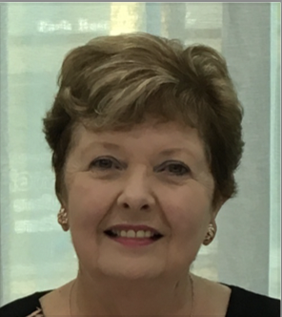

Mrs Witchell.

Examiner table requirements.

- Bottled water and a glass on the table
- Hand Sanitiser
- Tissues
- Tablecloth
- Small rubbish bin under the table
- An extension lead should be available for Examiners using laptops
- Teachers MUST provide the Examiner/s with a suitable chair (supporting back is recommended)
- It is important to ensure the Examiner is comfortable in all climates, this may require additional heating or fans

Mrs Witchell.

Examiner catering requirements.

- Stringent Hygiene procedures followed with all preparation of meals and refreshments
- Cutlery to be supplied with all meals including serviettes

Examiner preferences.
- Preferred Title when examining
Miss Witchell

- Use of Laptop in the Exam Room (Teacher to supply electrical lead / power board)
Yes

- Allergies / Foods that cannot be eaten
None

- Morning Tea - Preferred Beverage and Snack
Savoury / Earl Grey Tea

- Lunch - Preferred Beverage and Food
Soup / Salad / Sandwich or Roll (no processed meat)

- Afternoon Tea - Preferred Beverage and Snack
Savoury / Earl Grey Tea

