I was nominated to the Board of Directors of ATOD early in my career to serve as a Board member and then President for a period of seven years. This was a wonderful time of my life as I worked hard alongside others to develop the company of ATOD.
I have been involved in many projects commissioned by ATOD including the ‘Imagine’ preschool program and the Pre level assessments, a great deal of syllabi development including re drafting the 2022 syllabi notes for the ATOD teacher’s platform online, assisting with the new report writer comment bank, assisting with the application to the Qld Education of Senior school credits (QCAA) and preparing resources for the RTO branch of the company.
My studio was sold in 2013 to my daughter and fellow examiner Heidi O’Hehir who has on sold to former student and studio owner Claire O’Shea in July 2022. The legacy lives on and I am more than proud of our achievements.
I encourage all members of ATOD to become fully involved in the company as there is much to be gained and to learn from this experience.
My teaching tip is to enhance the training of your students by learning as much as you can yourself, no matter which genre or age you are working with. As a previously trained and past practicing school teacher, I believe each student has the right to a complete level of safe dance training that suits their personal learning style. While this is not an easy task for any studio dance teacher, it is in my opinion, paramount to success for one and all.

Examiner Bio.
Having examined extensively throughout Australia and internationally, I have gained a great deal regarding dance, and consider this period one of my biggest learning curves.
As a studio owner myself for 33 years at Maroochydore on the Sunshine Coast, I have probably educated thousands of students in many genres to advanced levels including students becoming Associate Teachers and higher, and students winning both State and Australasian scholarships in all genre of ballet, tap and jazz. Some have gone on to professional careers, some pre professional training and further careers from there, university training in dance and fine arts, and many have opened their own dance studios or are teaching dance in secondary colleges.

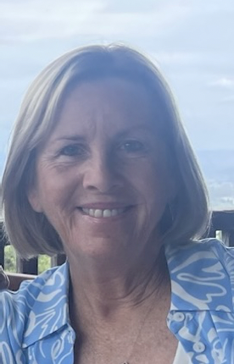
Mrs Dalton.

Mrs Dalton.

Examiner catering requirements.

- Stringent Hygiene procedures followed with all preparation of meals and refreshments
- Cutlery to be supplied with all meals including serviettes

Examiner table requirements.

- Bottled water and a glass on the table
- Hand Sanitiser
- Tissues
- Tablecloth
- Small rubbish bin under the table
- An extension lead should be available for Examiners using laptops
- Teachers MUST provide the Examiner/s with a suitable chair (supporting back is recommended)
- It is important to ensure the Examiner is comfortable in all climates, this may require additional heating or fans

Examiner preferences.
- Preferred Title when examining
Mrs Dalton

- Use of Laptop in the Exam Room (Teacher to supply electrical lead / power board)
Yes

- Allergies / Foods that cannot be eaten
Processed meats

- Morning/Afternoon Tea - Preferred Beverage and Snack
Coffee 1/2 strength latte or black tea. No sugar

- Lunch - Preferred Beverage and Food
Chicken, quiche, limited bread, soups. Water drink or juice

